Biology Circus

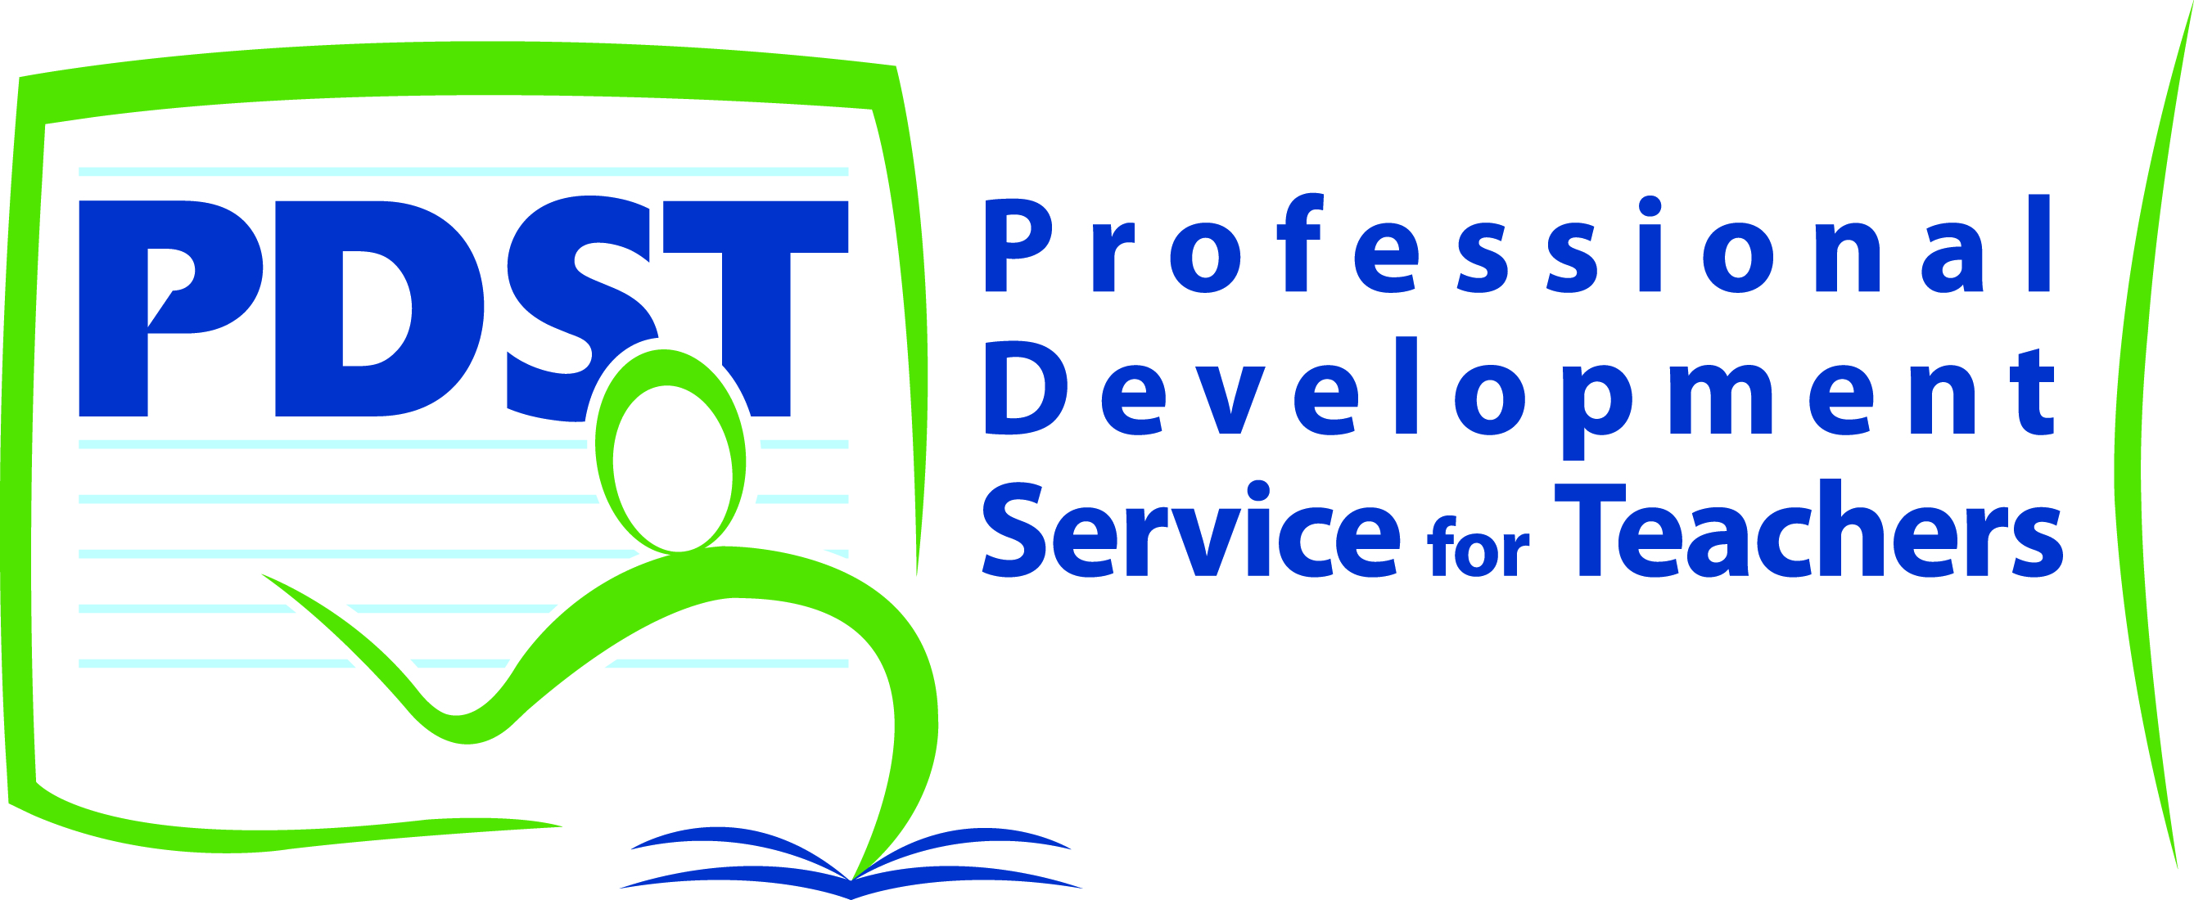

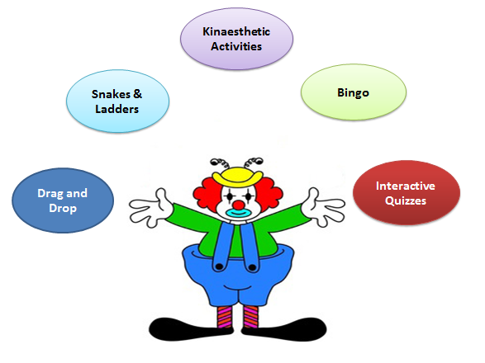
Biology games to support Teaching and Learning Biology
An opportunity for Biology teachers to try various games designed to support the teaching and learning of biology. The games include computer based interactive quizzes, drag and drop kinaesthetic activities, snakes and ladders, bingo and more.
This workshop will provide new and experienced teachers with a wealth of teaching strategies, resources, activities, and ideas to enhance the teaching and learning of biology. These resources are designed to stimulate student interest, engagement and involvement. As students engage in these activities in your classroom, they develop their
- Literacy skills
- Higher order reasoning skills,
- A deeper understanding of scientific concepts and scientific knowledge
All participants will receive a free DVD. On this DVD teachers will find ready-to-use animations, games and puzzles.
The DVD also includes resources for Ordinary Level Biology as well as interactive revision resources based on SEC material which can be used by students in class or for independent revision at home.

