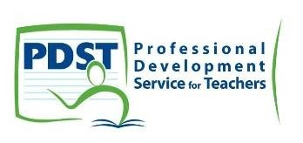
Schoology
PDST Chemistry: Make & Take Workshop

Schoology is an innovative learning management system (LMS) and social network that makes it easy to create and share academic content. Schoology lets you manage your classroom, engage your students, find resources, and connect to other teachers anytime, anywhere.
With an easy-to-use collaborative interface, Schoology empowers engaging instruction and system-wide collaboration to enhance the overall impact of everyone involved. Schoology centralizes all your academic content and simplifies management so you can spend more time teaching and less time managing your classroom. Experience the power of a global learning community. Build connections and collaborate with your peers.
Schoology.com is a social networking service and virtual learning environment for school and higher education institutions that allows users to create, manage, and share academic content. Also known as a learning management system (LMS) or course management system (CMS), the cloud-based platform provides tools needed to manage an online classroom.
Visually and functionally similar to Facebook, the service includes attendance records, online gradebook, tests and quizzes, and homework dropboxes. The social media features facilitate collaboration among a class, a group, or a school. Schoology can be integrated with existing school reporting and information systems and also provides the added security, filters and support that schools require.
Schoology is offered to individual teachers and schools free of charge. When you have completed a topic you can make all your resources available to your students online for revision and it would also benefit absent students. Your resources can be uploaded to the cloud and distributed to individual classes as required. PowerPoints, animations, flashcards and Youtube videos can be made available for students to view online or download.
This workshop will allow you a hands-on opportunity to create your own courses for your students so that when you return to school you are ready to begin enrolment.
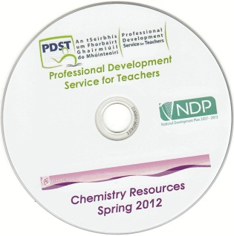
All participants will receive free resources at this workshop.

