Title: Understanding Sound & Music
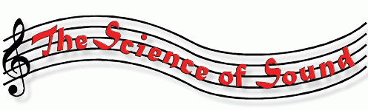

Abstract: This lecture will deal with various aspects of sound and music: the nature of sound, waves, reflection, diffraction, interference, harmonics, music, scales and chords. The lecture will include many demonstrations.

